1. **Collections**:
   1. Utilization Class.
   2. Many useful methods.
   3. But we will focus on synchronization methods for collection.
2. 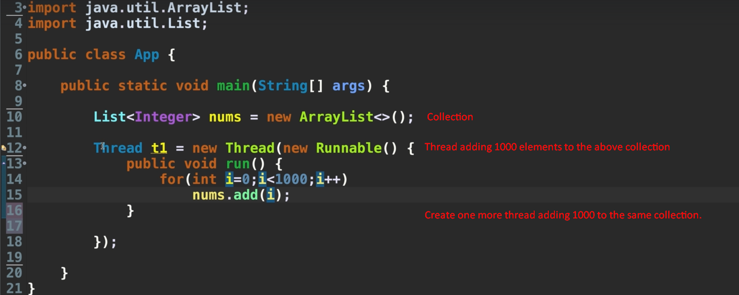
3. 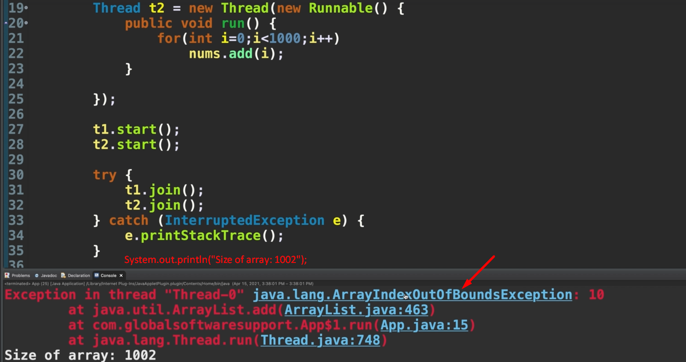
4. 